
IQRA 1447
Level 1 · Game Sheets
Name: ________________________________________
Connect the Dots 1 · Section 1 · The Letters — Start at the dot with a ring. Join the dots in this order, then join the last one back to the first.
ا ب ت ث ج ح خ د ذ ر ز س ش ص ض ط ظ ع غ ف ق ك ل م ن هـ و ي
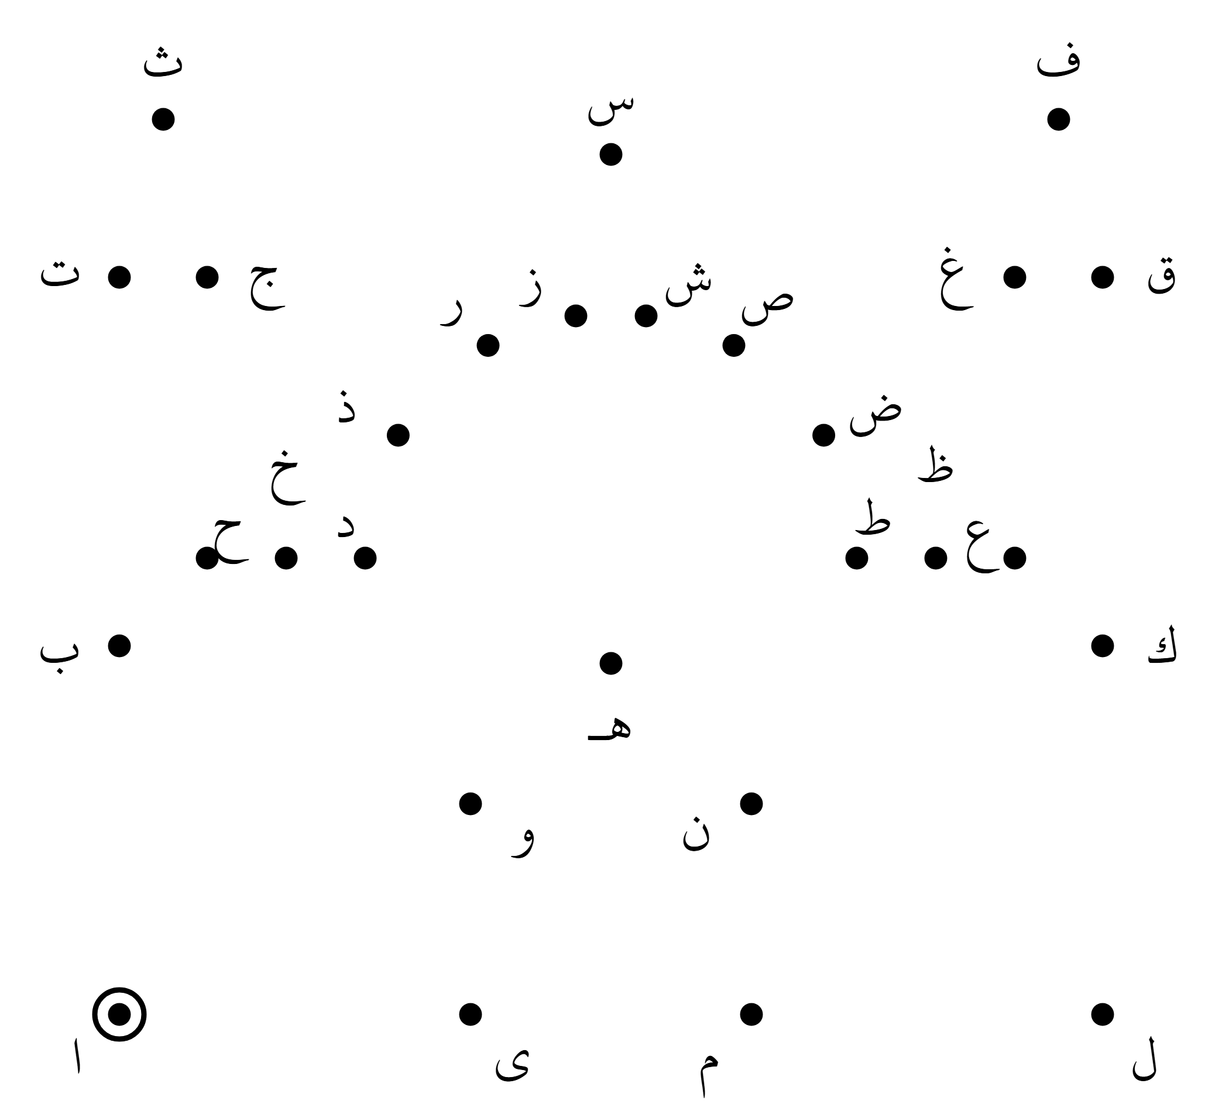

What did you draw? _____________________________ Now color it in!
IQRA 1447
Level 1 · Game Sheets
Name: ________________________________________
Connect the Dots 2 · Section 3 · Harakat — Start at the dot with a ring. Join the dots in this order, then join the last one back to the first.
بَ بُ بِ تَ تُ تِ ثَ ثُ ثِ جَ جُ جِ حَ حُ حِ خَ خُ خِ دَ دُ دِ ذَ ذُ ذِ رَ رُ رِ
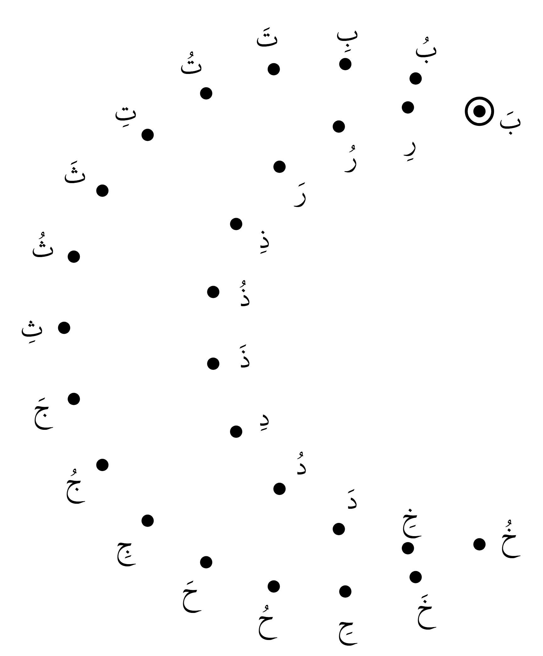

What did you draw? _____________________________ Now color it in!
IQRA 1447
Level 1 · Game Sheets
Name: ________________________________________
Connect the Dots 3 · Section 4 · Tanween — Start at the dot with a ring. Join the dots in this order, then join the last one back to the first.
بًا بٌ بٍ تًا تٌ تٍ ثًا ثٌ ثٍ جًا جٌ جٍ حًا حٌ حٍ خًا خٌ خٍ دًا دٌ دٍ ذًا ذٌ ذٍ
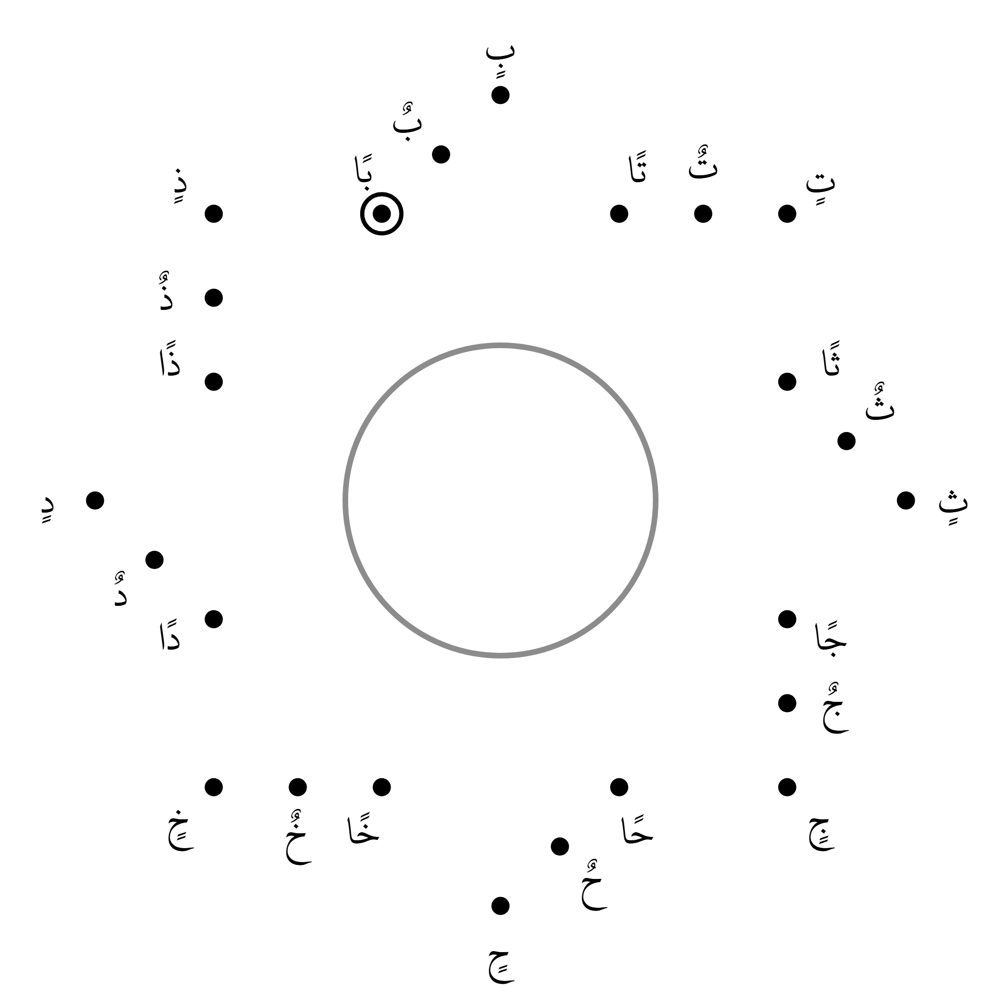

What did you draw? _____________________________ Now color it in!

